**Experiment 2:-**

Design an LED Chaser

**Circuit Diagram:-**

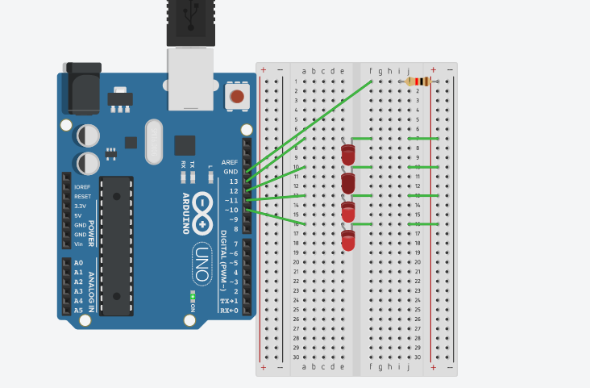

**Theory:-**

**Concept Used:-**

The concepts used while doing this experiment are:-

* The arduino board can supply a power of 5V as digital output signals through the 14 pins.
* The GND pin of the arduino board acts as ground.
* In the bread board present in the above circuit diagram the two rows present at the top and bottom each, are connected with each other in series and the columns present in between are connected in a set of 5 each. The connection pattern is shown below: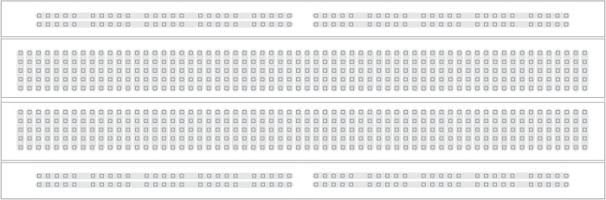
* Kirchoff’s current law:-Total current that is flowing in a junction is equal to current flowing out of that junction.
* Ohm’s Law:-Ohm’s law states that the current through a conductor is directly proportional to the voltage across the two points provided that the physical conditions remains constant.

V=IR

**Learning and Observation:-**

**Learnings:-**

* I have learned to make a parallel circuit connection using an arduino board and a breadboard.
* I have learned to make different glowing patterns of LED.

**Observations:-**

* I observed that first two LED glows and then the first LED goes off and the third one glows and the pattern like this continues.

**Problems and Troubleshooting:-**

* The LEDs were not working properly.
* The wire of the Arduino board was not in a working condition due to which the code was not working.

**Precautions:-**

The precautions that we need to remember while doing this experiment are:-

* The wires are inserted properly.
* Polarity of the devices should be kept in mind while plugging them.

**Learning Outcomes:-**

* I have gained the skill of making different kind of patterns of light using LEDs.
* I have learned to work with an Arduino board and make different patterns.